

**Redstor Plugin Configuration Guide**

Contents

Configuration Checklist 1

Supported Collection Types 2

Data Sources 2

Requirements 2

Firewall Ports 2

Setup 2

Server Properties 3

Field Definitions 3

Customer Tenant Management 4

Initial Tenant Discovery 4

Updating Tenants (Onboard/Offboard) 5

Troubleshooting 5

Test Connection 5

Reporting Notes 5

Technical Support 6

# Configuration Checklist

Here is a quick checklist for deployment of Redstor. Detailed instructions are in sections below.

Ensure the following information is available when configuring an Redstor server:

Admin username and password

# Supported Collection Types

The plugin supports the following collection types from Redstor:

|  |  |  |
| --- | --- | --- |
| **Collection Type** | **Supported** | **Description** |
| Backup | ✓ | Collects transactional details about backups. Example metrics include, start times, durations, bytes, and errors, etc. |
| Storage |  | Collects point-in-time inventory information. Example metrics include, total recoverable gigabytes (storage), media volume count, media volume status, etc. |
| Policy | ✓ | Collects and stores information on tenants. |

# Data Sources

The plugin relies on the following Redstor data sources:

* Redstor REST API

Please make sure to have Redstor administrator login credentials handy. This is the same Username and Password you use to administer the Redstor Pro Console.

Bocada pre-populates the Data Center URL with Redstor’s preview server. You’ll need to change this to your Redstor Odata endpoint (probably something like https://zasp.pro.redstor.com/api/odata).

# Requirements

This section lists requirements that must be met prior to collecting data with the Bocada plugin for Redstor.

### Firewall Ports

|  |  |  |
| --- | --- | --- |
| **Service** | **Default Port** | **Note** |
| HTTPS | 443 | Outbound from DCS to Redstor API |

# Setup

### Server Properties

Backup Server Properties determine how the plugin will interface with the Redstor and are managed through the Backup Servers view.

### Field Definitions

#### Server name

Enter a name for the Redstor instance that you wish to see within Bocada. Use descriptive name within Bocada to associate with Redstor instance.

#### User Name

Enter the admin username that allows accessing Redstor.

#### Password

Enter the admin password that allows accessing Redstor.

#### Data Center URL

Enter the Data Center URL described in the above checklist.

#### Time Zone

Select the time zone where Redstor server resides. This setting ensures times are displayed consistently in environments that span multiple time zones.

#### Discover Tenants

Clicking “DISCOVER TENANTS” will provide an interface to choose which customer/client tenants to include in reporting (and licensing). For detailed information see Customer Tenant Management

# **Customer Tenant Management**

The Redstor Bocada plugin offers a way to manage which Redstor groups are included in the reporting and licensing. If you do not need Tenant Management - you can skip these steps, in this case, the plugin will collect data based on all tenants, also zones and rules per tenant will not be created.

### **Initial Tenant Discovery**

When first adding a server, you can perform a tenant discovery. Clicking the “DISCOVER TENANTS” button will add the Redstor server to Bocada, save the properties, perform a test connection, and run a policy update to discover available customer/client tenants.

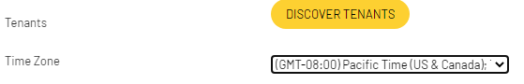

Depending on how long discovery takes to complete – after it will launch a butterfly control to select which tenants to include in reporting (and licensing).

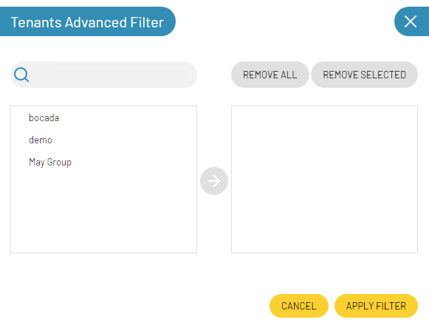

Highlight the available tenants from the left side and click the blue center arrow to include those tenants in reporting and licensing.

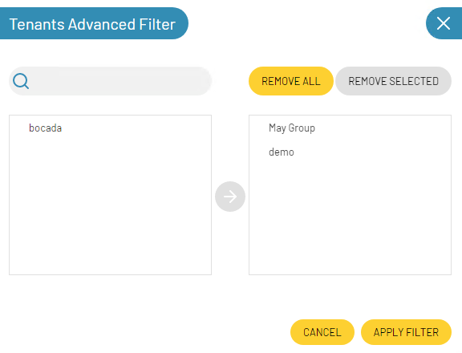

When you finish selecting tenants, APPLY FILTER to report on those present on the right side. Upon completing the server configuration, a corresponding set of zones and rules will be created to reproduce the Redstor multi-tenancy and when rules are run the data for each tenant will be assigned to the corresponding zones.

### **Updating Tenants (Onboard/Offboard)**

At any point customers can be added to or removed from Bocada reporting by following the above process when editing the Redstor server. When offboarding a customer (removing from the reporting) additional steps should also be taken to remove them from report distribution. Any unit count related to that customer will automatically fall off the license count after 35 days.

# Troubleshooting

## Test Connection

Test Connection is using server properties to get limited backup activities, check the message for the reason.

The message ‘test connection successful’ indicates events are collected successfully; Otherwise, the message should tell the user the specific error.

If the message is ‘Test connection failed’, this could be due to incorrect server settings API configuration. Try running data collection updates to see if any backup is being collected.

If no data is collected, further diagnostic may be required, using postman for example.

# Reporting Notes

There are currently no dedicated reporting notes for Redstor.

# Technical Support

For technical support, or for a copy of our standard support agreement, please contact us.

**E-mail:** [support@bocada.com](mailto:support@bocada.com)

**Support Portal:** <https://bocada-support.force.com>

**Phone:** +1-425-898-2400